Lab 6: Design of a Simple General-Purpose Processor

Table of Contents

Introduction ------------------------------------------------------------------------------------- 2

Components: Latch1, Latch2, 4:16 Decoder, FSM ------------------------------------- 2

ALU_1 for Problem Set 1 --------------------------------------------------------------------- 8

ALU_2 for Problem Set 2 --------------------------------------------------------------------- 11

ALU_3 for Problem Set 3 --------------------------------------------------------------------- 13

Conclusion ---------------------------------------------------------------------------------------- 16

Components: Latch1, Latch2, 4:16 Decoder, FSM

Latch1:
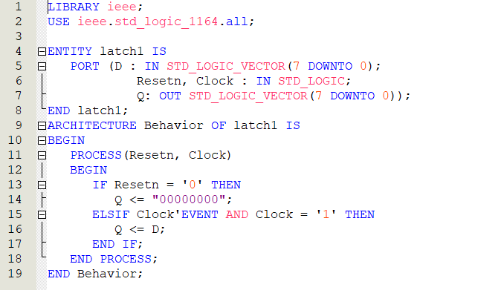

Latch2:
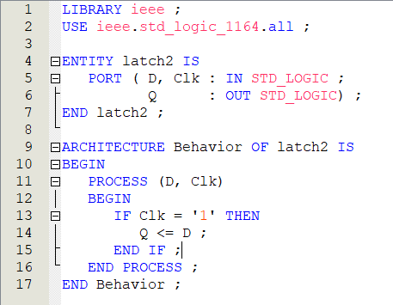

4:16 Decoder:
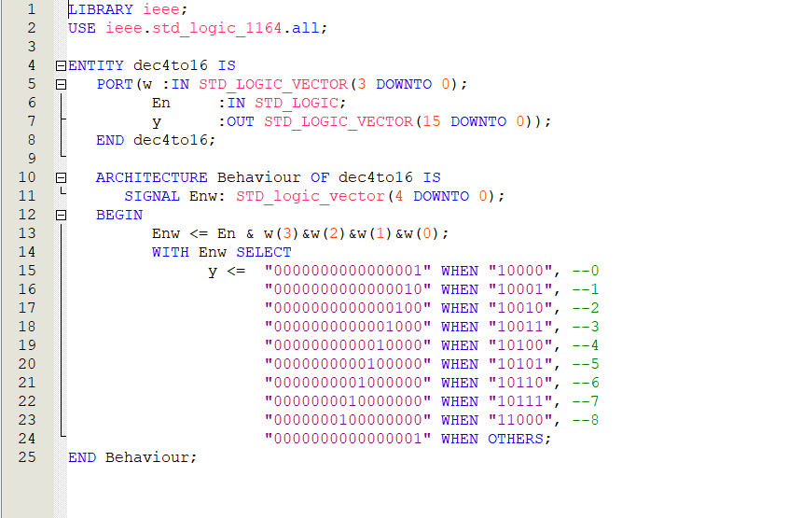

FSM:
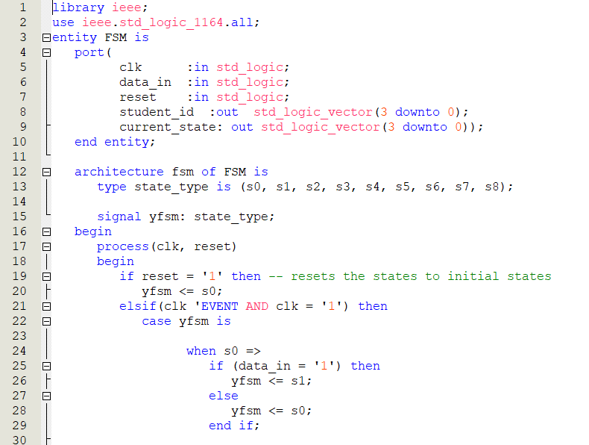
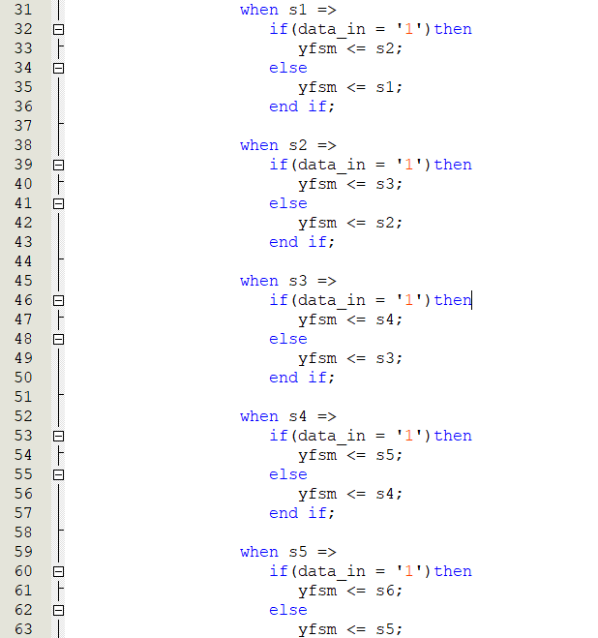
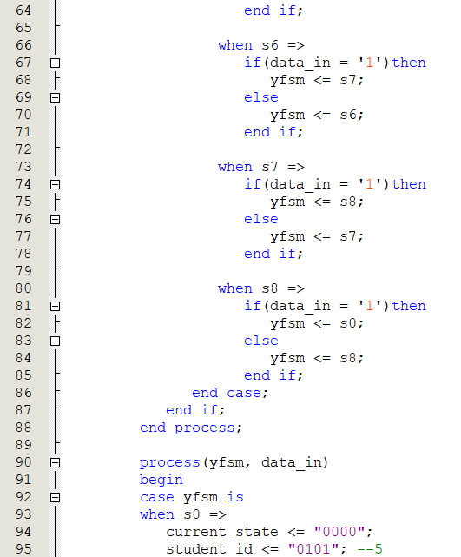
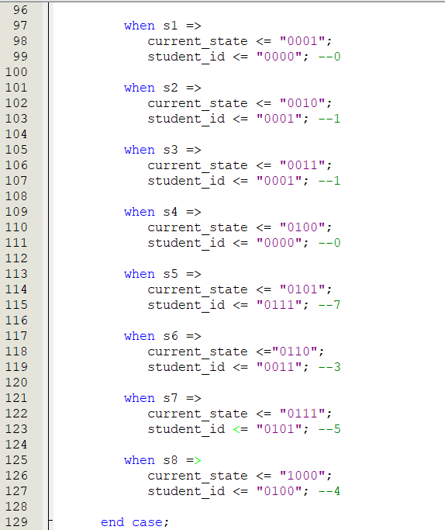

Latch 1 is a storage unit (register) which temporarily stores the value of input A. It reads the bit values of A on the rising edge of the clock signal and passes those value into the output port in the next rising edge of the clock signal. It forms an 8-bit output. Latch 2 is basically like latch 1 but it involves values of input B.
FSM is one of the subcomponents of the control unit that determines the patter of the controller sequence. The FSM cycles 9 states from states 0 to 8 through using the clock signals. The student id was displayed on the 7-segment. The FSM then takes the clock signal as the input and forms a 4-bit output which is passed to the decoder.
The 4:16 decoder receives the signal current_state from the FSM and decodes it to the operation-selector microcode. A 3:8 decoder from a previous lab was extended to become a 4:16 decoder.

ALU_1 for Problem Set 1
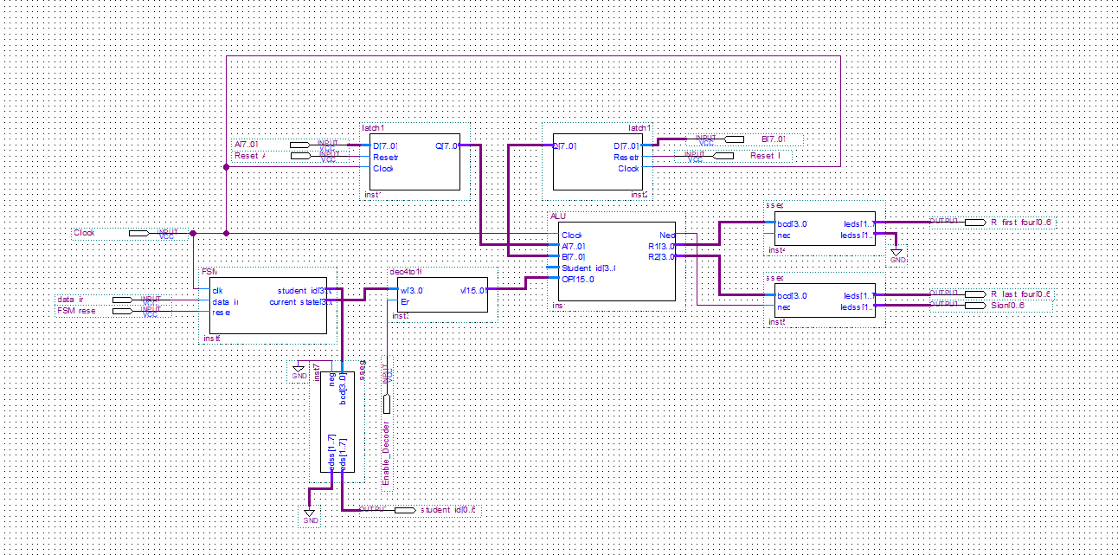
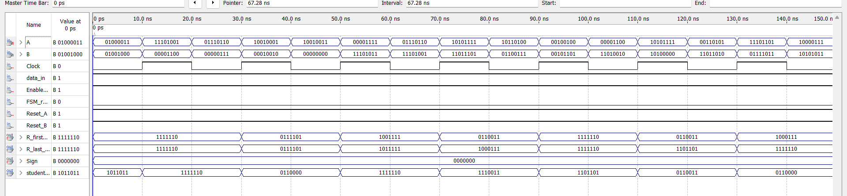
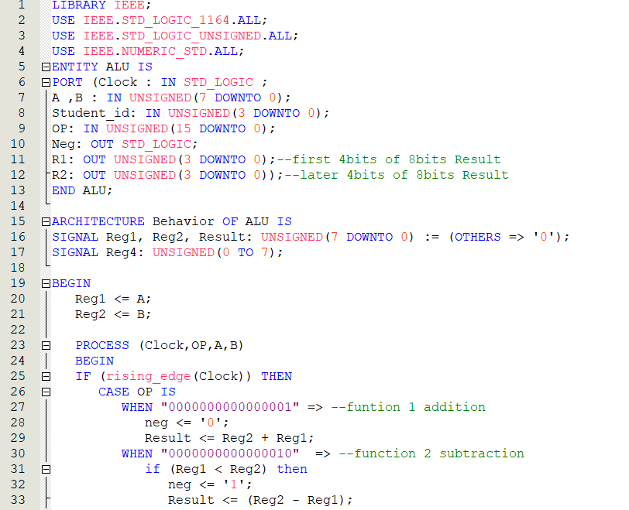
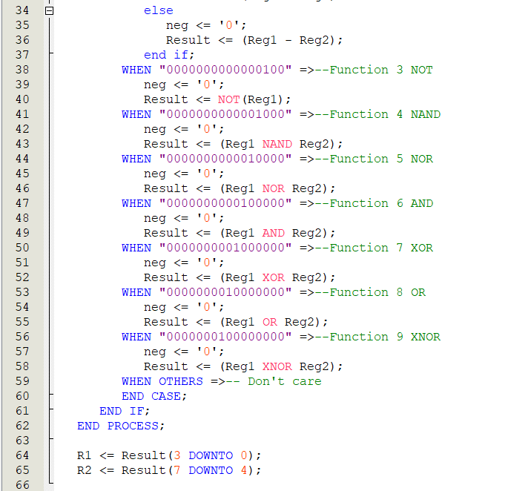

ALU_2 for Problem Set 2
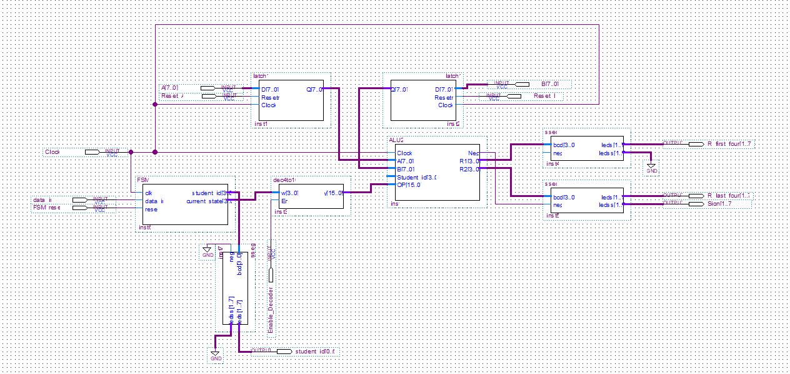
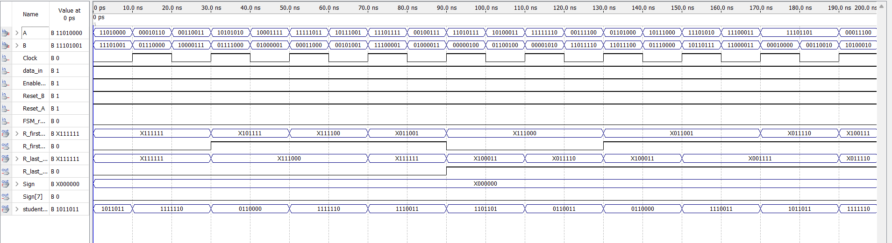
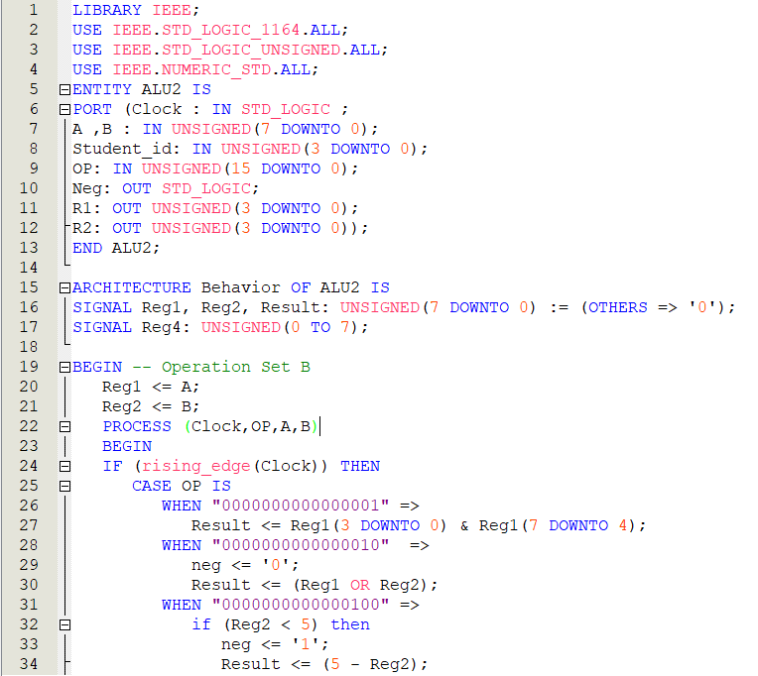
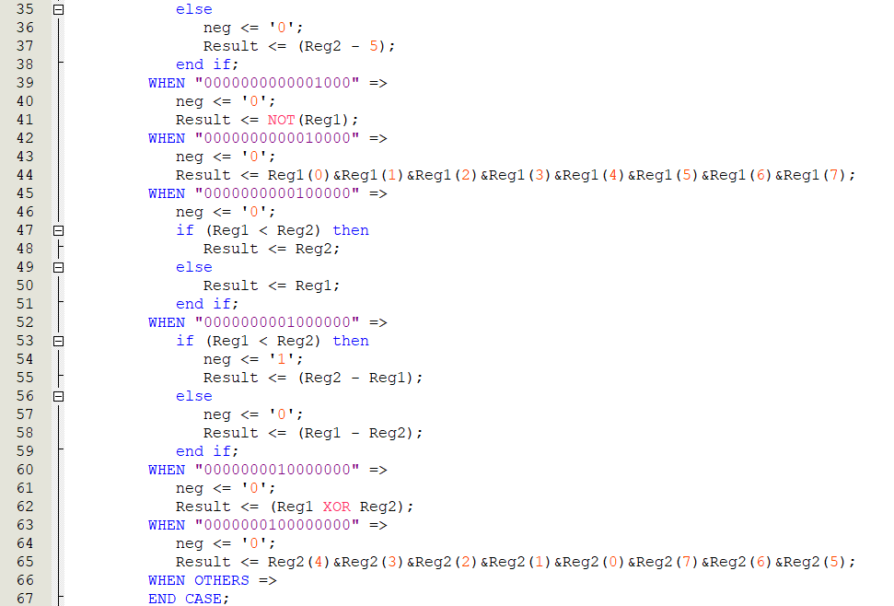
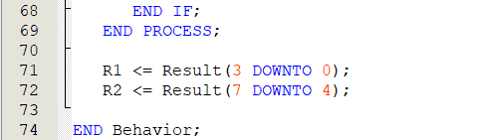

ALU_3 for Problem Set 3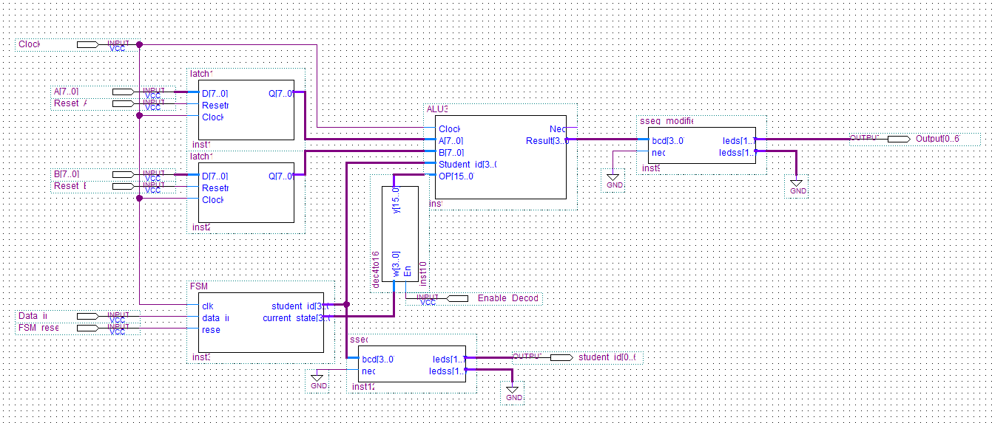
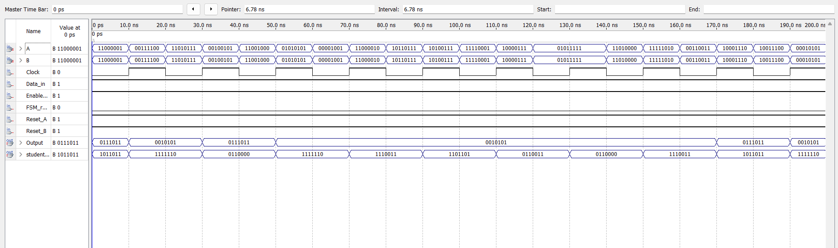
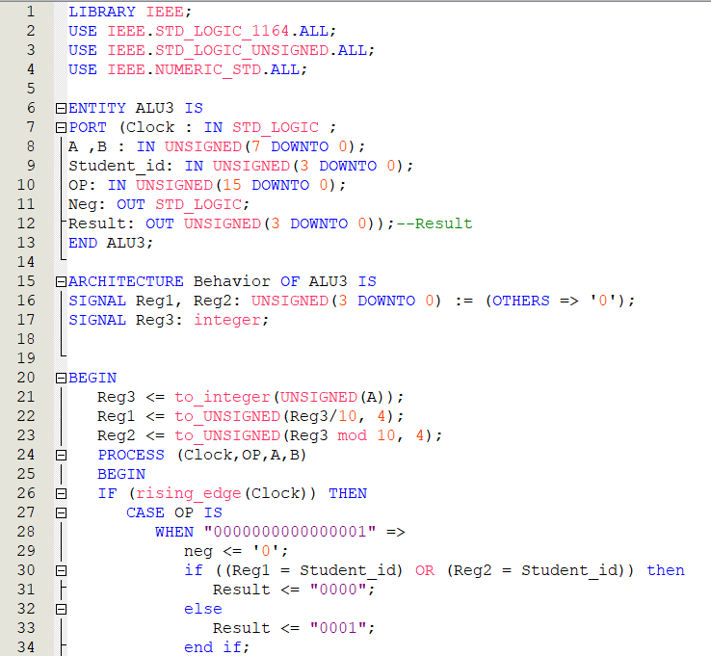
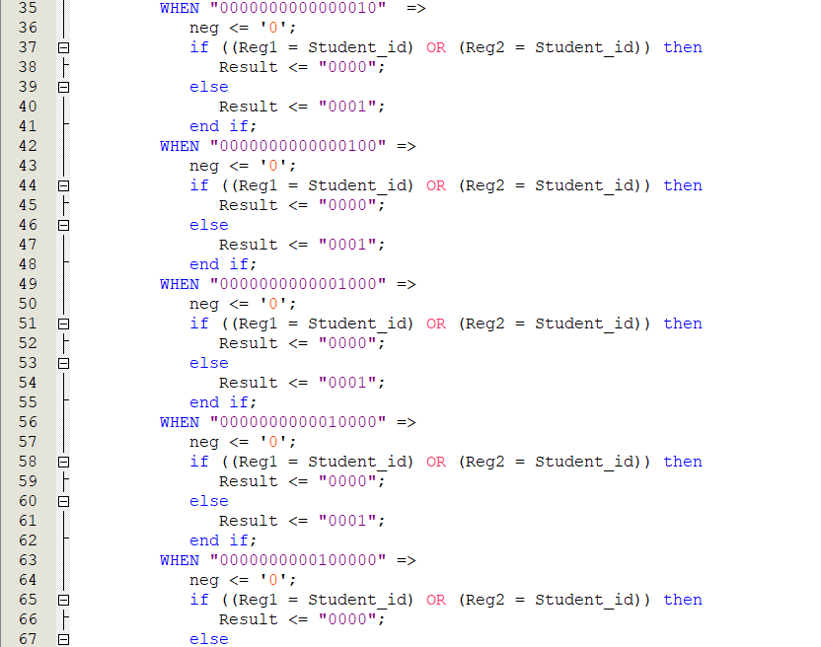
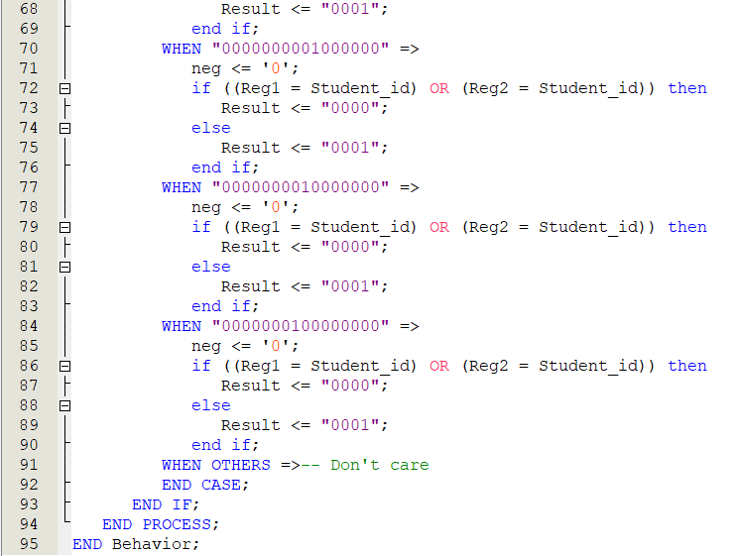

Conclusion
In conclusion, I learned how to create an Arithmetic Logic Unit and implement in VHDL and put it on a FPGA board. I was able to build all the function in the ALU and simulate it using VHDL code with the Quartus Simulator.

